Pokhara University

Level: Bachelor | Semester – Spring | Year : 2006
Programme: BE |  | Full Marks: 100
Course: Electronic Circuits |  | Time : 3hrs.

Candidates are required to give their answers in their own words as far as practicable.
The figures in the margin indicate full marks.

Attempt all the questions.

 | - Darlington pair can be regarded as a "Super beta" transistor. Verify the statement.  - For the given single stage CE amplifier, find:  - input impedance  - the effective ac load resistance of the transistor  - voltage gain  - V_{out} if V_{s} = 1 mV rms.  (Assume β = 100, V_{CC} = +20V)  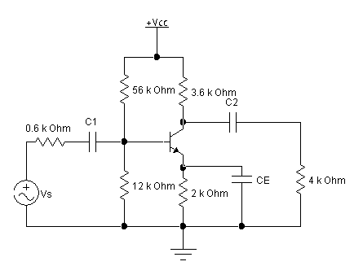 | 4  2  2  2  2
 | - Explain about the choice of transistor configuration in cascaded system. | 3
 | - Draw gain versus frequency graph for single stage CE amplifier. Define lower cut-off frequency, upper cut-off frequency and bandwidth. Find out the value of the lower cut-off frequency for the circuit given in Q.N.1.(b). (Assume C₁ = 25 μF, C₂ = 25 μF, C_{E} = 100μF).  - In class B complementary symmetry push-pull amplifier, the average load power is 20 W and load resistance is 8 Ω. The power supply should be 4 V greater than the peak sine wave output voltage. Determine the peak output voltage, the power supply voltage required, the peak current from each supply, the total supply power, power conversion efficiency and the maximum power that each transistor must dissipate safely.  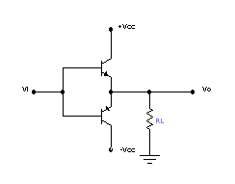 | 7  8
 | - Derive the expression of gain (A_{f}) of negative feedback amplifier. What are the main advantages and disadvantages of negative feedback amplifier?  - Show that maximum possible efficiency of the series fed class A amplifier is only 25%.  - Explain the working principle of "Successive Approximation Type" A/D converter. | 5  5  5
 | - A Colpitt Oscillator is designed with C₂ =100 pF and C₁ = 7500 pF. The inductance is variable. Determine the range of inductance values if the frequency of Oscillation is to vary between 950 KHz to 1050 KHz.  - Calculate voltage gain, input and output impedance with feedback for voltage series feedback having A = 300, R_{i} = 1.5KΩ, R₀=50KΩ and 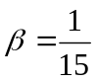 | 9  6
 | - What are the main characteristics of an operational amplifier?  - Define following terms: CMRR, Slew Rate, Input offset current, Output offset voltage and virtual ground.  - Design a practical differentiator that will differentiate signals with frequencies up to 200 Hz. The gain at 10 Hz should be 0.1. | 5  5  5
 | - With the help of circuit diagram, explain staircase ramp type (or counting type) ADC. What are its main disadvantages?  - Draw the block diagram of the Switching Mode Power Supply (SMPS) and explain its working principle. | 8  7
 | Write short notes on (Any Two):  - Gain bandwidth product  - Differential Amplifier  - Gain margin and phase margin | 2×5

